**Protocol: Building Dye-Sensitized Solar Cells**

1. Identify necessary parts. Each team will have three bags, two of which contain items specifically for building and exploring solar cells. The third contains items for making gold and silver nanoparticles, which is related extra activity that will fill any remaining time. Unpack only bags A and B at this time.

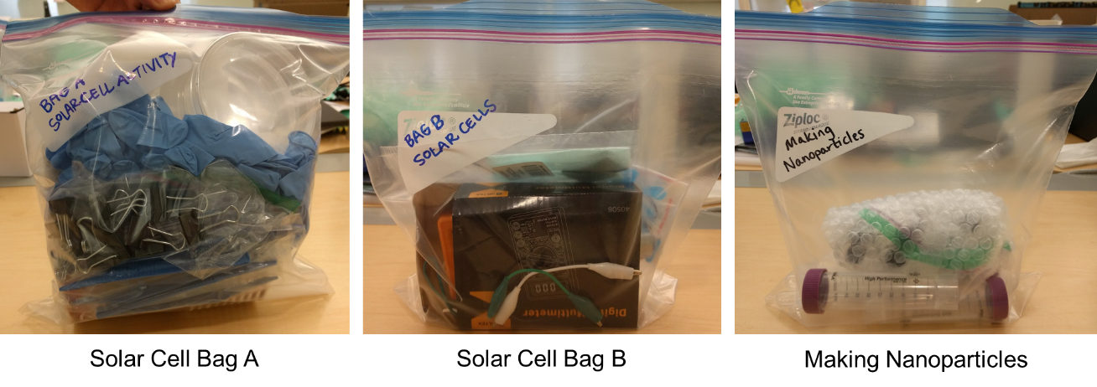

Contents of Bag A:

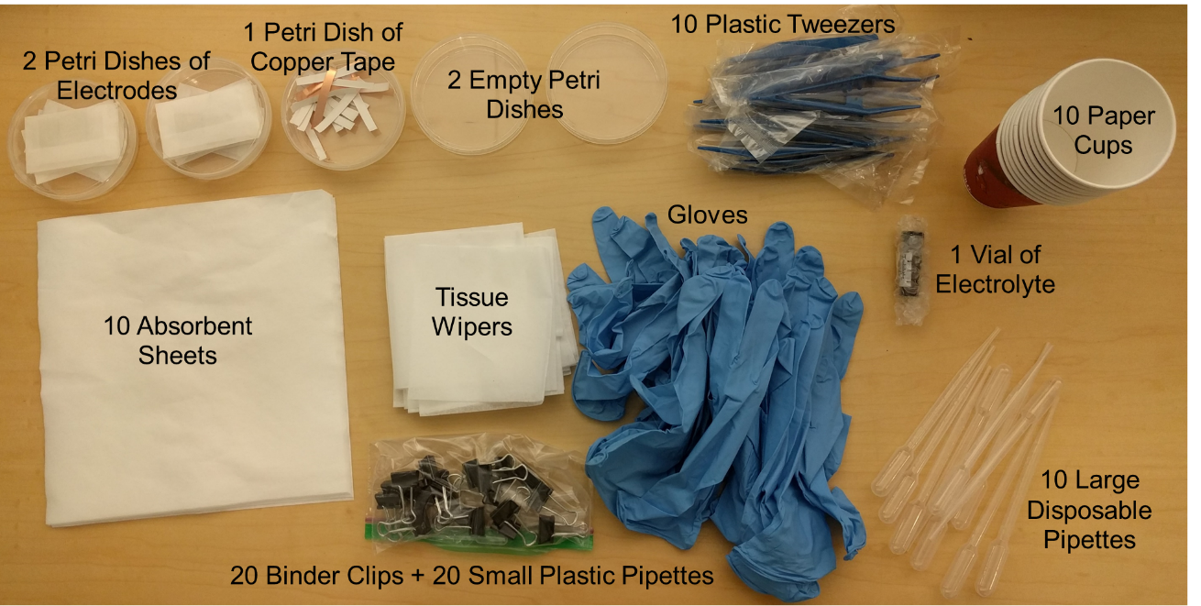

Contents of Bag B:

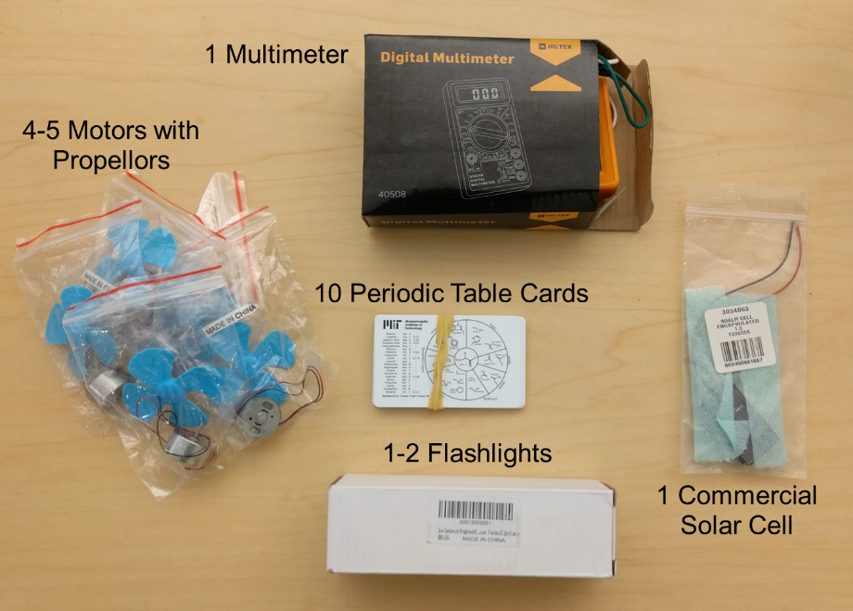

1. Lay an absorbent sheet on your table to delineate your individual workspace. Put on gloves.
2. Remove the electrodes from the petri dishes and envelopes. Do this very carefully, as a small transparent spacer is also in this envelope and should be placed aside. Be sure to keep very close track of this spacer for a later step. Each envelope contains two electrodes; one is coated with platinum nanoparticles and the other is coated with a titania paste. The platinum electrode has a tiny hole, while a faint square should be visible on the titania electrode. Lay these flat on your workspace.
3. Use the multimeter to identify which side of the electrodes is conducting. Do this by first turning on the multimeter, then turning the dial to the resistance (ohms) setting. The correct choice should be circled. Now touch the red and black leads to the surface of the electrode. If the correct side is up you will see a numerical reading on the multimeter. Keep the electrodes conducting-side up on your workspace.
4. The next step is to add the dye to the semiconducting titania paste. Two types of dye are available—hibiscus tea (brewed ahead of time) and juice from fresh berries. The tea seems to be much more effective in the time we have for this activity, so we recommend that all students use the tea for dying and if time allows, students can get together and make a second cell using berry juice. However, we will leave this choice up to the students (solar cells made with berries just may not work as well). Therefore, each student should be given ~3 berries and a plastic bag. Berries can be crushed in the bags, and if necessary, a small amount of isopropanol added to help extract more juices. The students can carefully pour the liquid into one petri dish (ten students can pour all of their juice into one dish). In order to actually dye the titania, use the large plastic pipettes to drop a small amount of tea or juice onto the titania square. This should be left for about ten minutes or so.
5. Following the dye incubation, use the plastic tweezers to pick up the electrode. Rinse it using a small amount of isopropanol (this will be placed in a petri dish for each group). Use a kimwipe to dry the edges of the electrode and allow the surface to dry for a few minutes before continuing.
6. The next step is to add conducting copper tape to the edges of the electrodes. In order to figure out where to add your tape, flip the platinum electrode onto the titania electrode, and cover the titania square but leave the edge of the titania electrode free (this may be more clear after watching the video). Wrap the free edges of both the titania electrode and the platinum electrode with copper tape. Note that the copper tape is not required for a functioning solar cell, and if the students have difficulties with wrapping the edges they can skip this step.
7. Be sure your electrodes are laying conducting side up on your workspace once again. Find your transparent spacer. Use the tweezers to place this spacer (also called a gasket) on the titania electrode around the titania square. The empty square in the gasket should align with the titania. This gasket should attach well to the electrode and provides a way to somewhat confine the electrolyte to this small area.
8. The next step is to add a few drops of electrolyte to the titania. The electrolyte is an iodine solution (not toxic, but it will stain clothing) and is stored in small amber vials (one vial per ten student group). Use the small (0.2 mL capacity) plastic pipettes to remove a very small amount of electrolyte from the vial, then drop approximately two drops onto the titania square.
9. Flip the platinum electrode onto the electrolyte spot in the same way as step 7 (with edges free). The conducting sides of both electrodes should face the inside of the sandwich you are making. Use a kimwipe to wipe away any excess electrolyte. Use binder clips to hold the electrodes together. This is your completed solar cell!
10. Test the solar cell by attaching the leads of the multimeter to the copper-taped edges. Technically the platinum electrode is the negative electrode (should connect to the black lead), but either way should work. Play around with the cell by illuminating in sunlight or with the provided flashlights. How does the signal change with light color or intensity?